Title of the Synopsis- 14 Times New Roman-Bold

Synopsis submitted
to
Shri Guru Ram Rai University in the partial fulfilment of the requirement for the degree of
Doctor of Philosophy
In
Subject:……………………
By
Name of Research scholar
Enrollment No.:


Supervisor Co-supervisor
(Name…………..) (Name:…………)

SHRI GURU RAM RAI UNIVERSITY
Patel Nagar Dehradun-248001, Uttarakhand
Batch (20….- 20….)
SHRI GURU RAM RAI UNIVERSITY
Patel Nagar, Dehradun-248001, Uttarakhand, India
(Estd. by Govt. of Uttarakhand, vide Shri Guru Ram Rai University Act no. 03 of 2017)

Certificate
This is to certify that Mr./Ms./Mrs…………………………………, a research scholar at Shri Guru Ram Rai University, Patel Nagar, Dehradun. He/she will work on the topic entitled “………………………………………………………………………….………………” under my supervision and guidance at Department ……………………………., College/Institute ………………………….. for the partial fulfillment of requirement for the degree of Ph.D in…………………(Session 20….-20….).

Date……………. Supervisor

Declaration by Research Scholar

I hereby declare that the synopsis of proposed research work entitled “……………………
………………………………………………………..” in fulfillment of the requirements for the award of degree of Doctor of Philosophy in subject of……………………………………….and submitted to Shri Guru Ram Rai University, Patel Nagar, Dehradun, Uttarakhand is an authentic record of bonafide research work will be carried out by me under the expert guidance as well as direct supervision of Prof./Dr……………………………..................... I further declare that the material obtained from other sources has been duly acknowledged in the synopsis.

Signature………………………....
Name……………………………..
Registration No…………………..
Department………………………

Title of the proposed research work:…………………………………………………………
……………………………………………………………………………………………………

Name of research Scholar:……………………………………………………………………

Name and designation of supervisor & co-supervisor/s:
1………………………………….….
……………………………………..

2…………………….……………….
………………………………………

3…………………..…………………
……………………………………..

Place of work:…………………………………………………………………………………….
…………………………………………………………………………………………………….

Signature:

- Research Scholar 2. Co-supervisor 3. Supervisor
……………………… …………………. ………………

Table of Contents

S. No. | Chapter | Page no.*
1 | Introduction and Research Justification/Rationale
2 | Literature Review, Research Gaps & Objective
3 | Research Methodology/ Materials & Methods
4 | Plan of work
5 | References
*Students are required to prepare a synopsis of up to 50 pages.

Text of the synopsis should be prepared as per following directions:
- Research scholars submitting their theses are required to comply with the following guidelines concerning paper size, text layout, and related specifications, except in exceptional cases where the concerned Faculty Head is satisfied that adherence to these requirements is not feasible.
- Size of the paper should be A4 (8.5" x 11.5") except for maps, drawing, and graphs.
- The text should be typed on one side of the paper leaving a margin of 4 cm on left hand side and 2 cm on right hand side as well as 2 cm at the top and 2 cm at the bottom.
- The text should be typed in 1.5 line spacing using normal type face/electronic typing/ PC word processing in 12 font size of Times New Roman (English Font) or 14/16 font size of Mangal/Kruti (Hindi Font); Fancy fonts are not allowed for text writing.
- Optimal length of the synopsis should be kept between 40-50 pages. However, in some special cases it can be less/more.
- Color of the binding:

- School of Basic & Applied Sciences: Yellow
- School of Education: Navy Blue
- School of Commerce & Management: Violet
- School of Agriculture: Green
- School of IM & HS: Red
- School of Pharmaceutical Sciences: Dark Blue
- School of Humanities: Black
- School of Computer & IT : Brown
- School of Paramedical: Orange
- School of Nursing: Pink
- School of Yogic Science: Saffron

Covering letter for submission of synopsis

From Date:
(Name) _________________
Roll No.: ________________
Research Scholar
Department of …………………………….
College …………………………………………

To
The Dean-Research
Shri Guru Ram Rai University,
Patel Nagar, Dehradun – 248001

Respected Sir,
Subject: Submission of Ph.D. Synopsis
I am submitting herewith four copies & one soft copy (in CD drive) of my synopsis entitled “…………………………………………………………………………………” for your kind perusal and consideration.
Thanking you,
Yours faithfully,
( )
( )
Research Supervisor
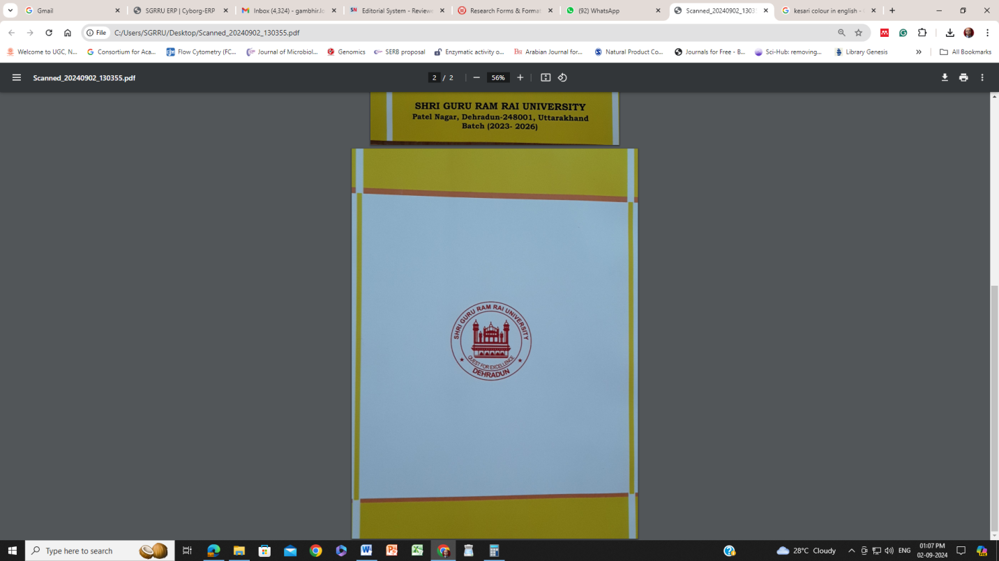
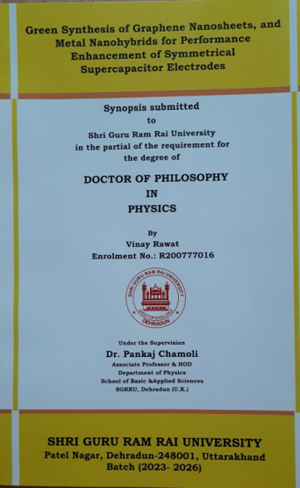
Front Page Design Back Page Design

